**Connecting EC2 with RDS Manually**

Create RDS with normal attributes

Step - 1 : Create EC2 webserver Linux AMI

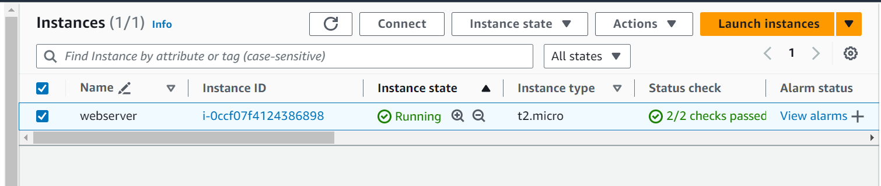

Step – 2 : SSH into EC2 instance

Step – 3 : sudo su – (Root user)

Step – 4 : yum update / dnf upgrade

Step – 5 : sudo dnf install -y httpd php php-mysqli mariadb105

Step – 6 : systemctl start httpd

Step – 7 : systemctl enable httpd

Step – 8 : cd /var/www

Step – 9 : mkdir inc

cd inc

vi dbinfo.inc

i

<?php

define('DB_SERVER', 'db_instance_endpoint');

define('DB_USERNAME', 'tutorial_user');

define('DB_PASSWORD', 'master password');

define('DB_DATABASE', 'sample');

?>

esc + :wq!

Step – 10 : cd /var/www/html

vi SamplePage.php

i

<?php include "../inc/dbinfo.inc"; ?>

<html>

<body>

<h1>Sample page</h1>

<?php

  /* Connect to MySQL and select the database. */

  $connection = mysqli_connect(DB_SERVER, DB_USERNAME, DB_PASSWORD);

  if (mysqli_connect_errno()) echo "Failed to connect to MySQL: " . mysqli_connect_error();

  $database = mysqli_select_db($connection, DB_DATABASE);

  /* Ensure that the EMPLOYEES table exists. */

  VerifyEmployeesTable($connection, DB_DATABASE);

  /* If input fields are populated, add a row to the EMPLOYEES table. */

  $employee_name = htmlentities($_POST['NAME']);

  $employee_address = htmlentities($_POST['ADDRESS']);

  if (strlen($employee_name) || strlen($employee_address)) {

    AddEmployee($connection, $employee_name, $employee_address);

  }

?>

<!-- Input form -->

<form action="<?PHP echo $_SERVER['SCRIPT_NAME'] ?>" method="POST">

  <table border="0">

    <tr>

      <td>NAME</td>

      <td>ADDRESS</td>

    </tr>

    <tr>

      <td>

        <input type="text" name="NAME" maxlength="45" size="30" />

      </td>

      <td>

        <input type="text" name="ADDRESS" maxlength="90" size="60" />

      </td>

      <td>

        <input type="submit" value="Add Data" />

      </td>

    </tr>

  </table>

</form>

<!-- Display table data. -->

<table border="1" cellpadding="2" cellspacing="2">

  <tr>

    <td>ID</td>

    <td>NAME</td>

    <td>ADDRESS</td>

  </tr>

<?php

$result = mysqli_query($connection, "SELECT * FROM EMPLOYEES");

while($query_data = mysqli_fetch_row($result)) {

  echo "<tr>";

  echo "<td>",$query_data[0], "</td>",

       "<td>",$query_data[1], "</td>",

       "<td>",$query_data[2], "</td>";

  echo "</tr>";

}

?>

</table>

<!-- Clean up. -->

<?php

  mysqli_free_result($result);

  mysqli_close($connection);

?>

</body>

</html>

<?php

/* Add an employee to the table. */

function AddEmployee($connection, $name, $address) {

   $n = mysqli_real_escape_string($connection, $name);

   $a = mysqli_real_escape_string($connection, $address);

   $query = "INSERT INTO EMPLOYEES (NAME, ADDRESS) VALUES ('$n', '$a');";

   if(!mysqli_query($connection, $query)) echo("<p>Error adding employee data.</p>");

}

/* Check whether the table exists and, if not, create it. */

function VerifyEmployeesTable($connection, $dbName) {

  if(!TableExists("EMPLOYEES", $connection, $dbName))

  {

     $query = "CREATE TABLE EMPLOYEES (

         ID int(11) UNSIGNED AUTO_INCREMENT PRIMARY KEY,

         NAME VARCHAR(45),

         ADDRESS VARCHAR(90)

       )";

     if(!mysqli_query($connection, $query)) echo("<p>Error creating table.</p>");

  }

}

/* Check for the existence of a table. */

function TableExists($tableName, $connection, $dbName) {

  $t = mysqli_real_escape_string($connection, $tableName);

  $d = mysqli_real_escape_string($connection, $dbName);

  $checktable = mysqli_query($connection,

      "SELECT TABLE_NAME FROM information_schema.TABLES WHERE TABLE_NAME = '$t' AND TABLE_SCHEMA = '$d'");

  if(mysqli_num_rows($checktable) > 0) return true;

  return false;

}

?>

Esc + :wq!

Step – 11 : After that, ssh ec2, then go to /var/www

Vi dbiinfo.inc

Edit the details with RDS details

Step – 12 : Go to RDS Security Group

Edit inbound rule -> delete and add rule

Custom TCP -> Port(3306) -> copy private IP of EC2 with ip/32 only 1 ip -> Add description

Alternative - Can also connect SG of EC2 to SG of RDS[optional]

Step – 13 : In SSH : mysql -h <endpoint> -u root -p

Password

Step – 14 : Show databases

Step – 15 : Use Sample

Step – 16 : Copy the EC2 public ip and give in browser like this

http://<publicip>/SamplePage.php

Step – 17 : Add the data inside the table

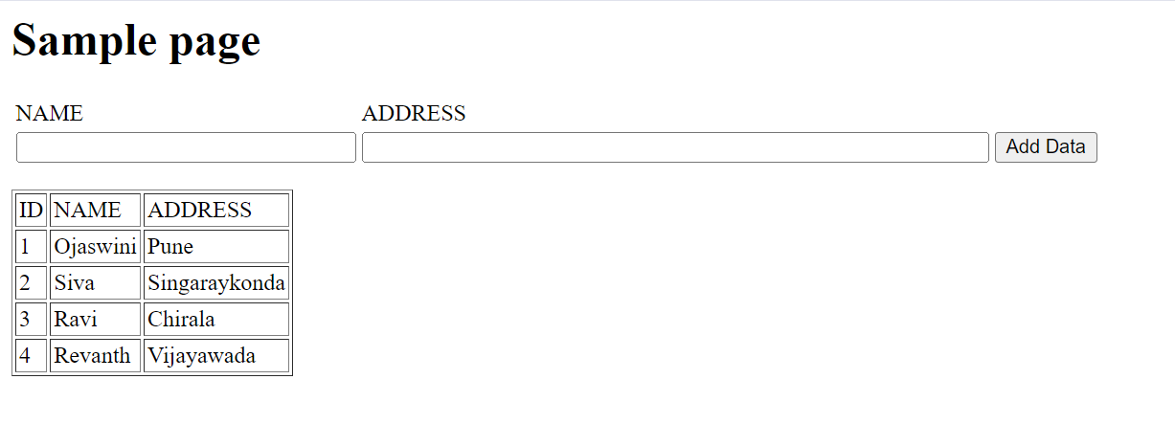

Step – 18 : Now go to EC2 SSH, then check the table EMPLOEES;

Now, you have completed the task.